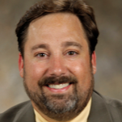
Ken Berta

Executive Director

As a Senior Executive at Philips Healthcare, Ken most recently served as the Global Lead for Strategic Partnerships and Alliances where he was responsible for managing relationships with Electronic Health Record (EHR), technology and application partners that impact the ecosystem of Philips customers and users.

Mr. Berta is the Co-founder of Cedar Grove Creek, LLC. and a principle in the firm’s consulting arm, MBTC Strategy Consultants. He has broad experience working with both public partners such as The Air Force Research Labs (AFRL), the Department of Veterans Affairs, FEMA, NATO, the Ohio Department of Development and Fortune 100 companies including Philips Healthcare, Siemens Healthcare, Dell Technologies and Hewlett Packard. Ken has also been a strategic advisor to large healthcare providers such as Ohio Health, The Kettering Health Network, The University of Toledo Health Network and Emory’s Innovation Hub led by 11|ten Innovation Partners. Cedar Grove Creek is also one of the founding investors of the Ohio Tech Angle Fund, a private/public economic development partnership with the Ohio Department of Development.

Mr. Berta started his career as a VA researcher, surgical technician and medical device designer. He quickly rose to the head of Global R&D for Ferno-Washington, one of the world’s largest private manufacturers and distributors of emergency medical products. After serving as the General Manager of Global Operations for YSI Life Sciences (now Xylem) he turned to public service to found - and was the EVP for - the non-profit Wright Center of Innovation for Advanced Data Management and Analysis (renamed daytaOhio). This state sponsored organization was made up of the AFRL, 5 Universities and 60 companies building Big Data solutions for Medicine, Energy and Defense.

While at daytaOhio, Mr. Berta was one of the leaders of the $200M bid for the development of the M.A.T.E. (medicine at the edge) center for extreme medical care - a private /public partnership between leading medical device companies, AFRL, HSA, FEMA and 4 academic medical centers. The resulting operation “Calamityville” is now the National Center for Medical Readiness that serves first responders, first receivers (physicians, nurses, mid-level providers, hospital staff), and Department of Defense (DoD) Special Operations units. With over 30 years of healthcare technology, strategic consulting and venture capital experience, Mr. Berta has designed and launched dozens of products, has been awarded 5 international patents, started 7 companies and received an executive appointment - The Order of the Ohio Commodore – the highest honor awarded a citizen by the Governor of Ohio.

Ken holds a degree in Biomedical Engineering focused on artificial organ design from Wright State University and an MBA in international business from the Williams School of business at Xavier University.

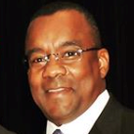
Monte Wilson

Incident Commander

As Hospital President and SVP for Wellstar Windy Hill Hospital, Mr. Wilson has over 20 years of experience in hospital administration and multiple tours leading incident commands. At Wellstar, he envisioned and directed Post-Acute Care operations, implemented system-wide business strategies and hospital alignment initiatives for the largest health system in Georgia consisting of 11 hospitals and an 1,100-member physician medical group.

Key responsibilities included identifying organization and departmental gaps and opportunities; developing strategic initiatives that benefit patients and staff with minimal operational disturbances while expanding growth opportunities; identifying staff and physician project champions and building effective teams. Responsible for the formation of Georgia’s largest Trauma Network; added four trauma centers aligned with WellStar’s existing trauma centers in coordination with the State of Georgia Public Health. Incident Commander for Wellstar for Ebola, Hurricane Katrina and Hurricane Sandy.

_______________

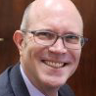
Leo Weakland

Director, Public Health Planning & Operations

Mr. Weakland has directed and managed international and domestic health programmes for over 30 years. He most recently served as the Senior Advisor for Strategic Management and Operations and guides and supports the development of public health programme management and business operational systems for advancing Africa CDC scientific and strategic goals and objectives within the context of the African Union. Prior to joining Africa CDC, Mr. Weakland served in a number of executive and line management functions with the US CDC, including serving as the Deputy Director, Division of Parasitic Diseases and Malaria and Associate Director for Management and Operations in the Division of Vector-Borne Diseases.

In his 28 years with CDC, Leo is most proud of his work in supporting research leading to the successful antiretroviral therapy and life-saving treatment of Africans living with HIV. His work in collaboration with WHO, UNICEF, the American Red Cross and the UN Foundation to support African Member State efforts to immunize children against measles helped achieve a 60% reduction in related mortality between 2002 and 2007 in Africa. Mr. Weakland holds a Master of Science in public health with specialization in health policy and administration from the University of North Carolina at Chapel Hill. He is fluent in English, French and Haitian Créole.

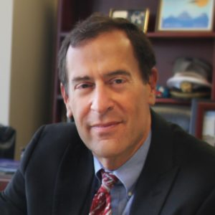
Rob Breiman, MD

Chief Scientific Officer

Dr. Breiman was most recently Director of the Emory Global Health Institute and holds faculty appointments in the Hubert Department of Global Health at the Rollins School of Public Health and in the Infectious Disease Department of the Emory University School of Medicine. During his over 30-year career in public health and academia, Dr. Brieman’s primary areas of research have been related to addressing inequities with focus on child mortality, urbanization in impoverished settings, and a range of respiratory and enteric diseases, as well as a variety of emerging infectious diseases.

In addition to his research, Dr. Breiman is currently working on translating global health work to increase public awareness and engagement. Until 2020, he was the Executive Director and Principal Investigator for the Child Health and Mortality Prevention Surveillance (CHAMPS) network. CHAMPS, funded by the Bill and Melinda Gates Foundation (BMGF), is designed to characterize and provide crucial data for preventing childhood mortality in Sub-Saharan Africa and South Asia; it currently works in S Africa, Mozambique, Kenya, Ethiopia, Mali, Sierra Leone, Bangladesh and India. Dr. Breiman has also been PI of BMGF and Gavi-funded projects focused on typhoid surveillance, rotavirus immunization impact, and characterizing the evolution of pneumococcal genetics globally during the era of pneumococcal conjugate vaccine use.

Before joining Emory in 2013, Dr. Breiman worked at CDC for 26 years. From 2004-2013, he was based in Nairobi, Kenya as the Director of CDC-Kenya’s Global Disease Detection Division, and for three years as overall Director of CDC-Kenya. Breiman was Head, of the Programme on Infectious Diseases and Vaccine Sciences at the internationally acclaimed International Center for Diarrheal Disease Research in Dhaka, Bangladesh (ICDDR, B) from 2000-2004. He was Director of the United States National Vaccine Program Office (NVPO) from 1995-2000 and was Chief of the Epidemiology Section of the Respiratory Diseases Branch (RDB) from 1989-1997. He served in the Epidemic Intelligence Service at CDC from 1987-1989 in RDB.

Dr. Breiman was elected into the National Academy of Medicine in 2017 and is a Fellow of the Infectious Diseases Society of America (IDSA) and the American Society of Tropical Medicine and Hygiene (ASTMH).

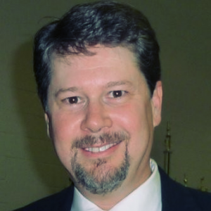
Rob Aaron

Healthcare IT & Strategic Alliance Lead

Rob is a Senior Global Healthcare IT Leader with 20 years of comprehensive health IT industry experience in global organizations including McKesson, Microsoft, Oracle and Philips. Rob developed and executed strategic alliances focused on transformative innovation, organic and inorganic growth that drives bottom line results. He has successfully negotiated and executed global strategic partnerships with cross-team collaboration including sales, services, marketing, R&D and product teams. Competencies include: New Solution Development, Joint Partner Plans and marketing roll out.

Rob is a HIMSS fellow and has been involved in HIMSS for over 12 years as a board member of the Georgia Chapter of HIMSS. Over this time, Rob has been President of the Chapter twice and was recently nominated by National HIMSS as a finalist for Chapter Leader of the Year. The HIMSS mission is to improve healthcare through information and technology.

At Philips, as the Director for Strategy and Business Development, Rob led the Alliances and Channels strategy for Population Health Management division. Rob developed, executed and maintained a partner playbook that incorporates Strategic Technology Partners (e.g. Amazon Web Services), System Integrators, and ISVs. Rob also sourced, evaluated, and executed new business opportunities, including strategic partnerships, strategic partner investments, and M&A.

At Oracle, as the Senior Director for Alliances and Channels, Rob managed the alliances and channels business for Oracle’s Health Sciences Global Business Unit. He provided leadership and expertise in the development of new joint solutions with partners, including cloud services offerings and processes designed to open new markets, strengthen new and existing partnerships, and produce high growth sales results.

At Microsoft, as the Global Alliance Lead for Healthcare, Rob developed a framework for assessing and selecting Microsoft’s global ISV alliances. Rob also managed Microsoft’s largest global healthcare partners. Rob built structured agreements (including product development and go-to-market agreements) that drove revenue for both Microsoft and partner.

Rob holds a BBA in International Business from the University of Georgia and an MA in Political Economy from the Ludwig Maximilian University (LMU in Munich, Germany) Rob is fluent in English and German.

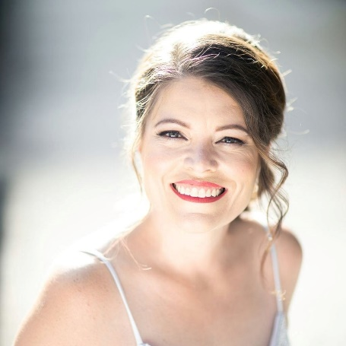
Brandy Mai

Public Information Officer

For two decades, Brandy has worked extensively in communications and public information, helping multiple organizations and agencies navigate their crisis communications and reputation strategies. Her experience includes work in military/veteran/government, corporate, nonprofit, emergency management, homeland security, and public safety sectors, including a position as lead public information officer for a state emergency management agency. Brandy's certifications as an emergency manager and POST Instructor allow her to manage crisis and teach public safety professionals how to coordinate information efficiently and effectively during preparedness, response, recovery, and mitigation efforts.

Brandy's education includes military public affairs training at the Defense Information School, Bachelor of Journalism from Northwestern State University, graduate coursework in strategic communications from Purdue University. She is also a current law student, giving her the legal knowledge to support her communications efforts. Her successes include a statewide Top 40 Under 40 award in Georgia for her public relations work with veteran nonprofits, contributions on an Emmy Award-winning project, placement of a previous employer on the Inc. 5000 “fastest growing company” list, and student bar election as representative to the American Bar Association.

