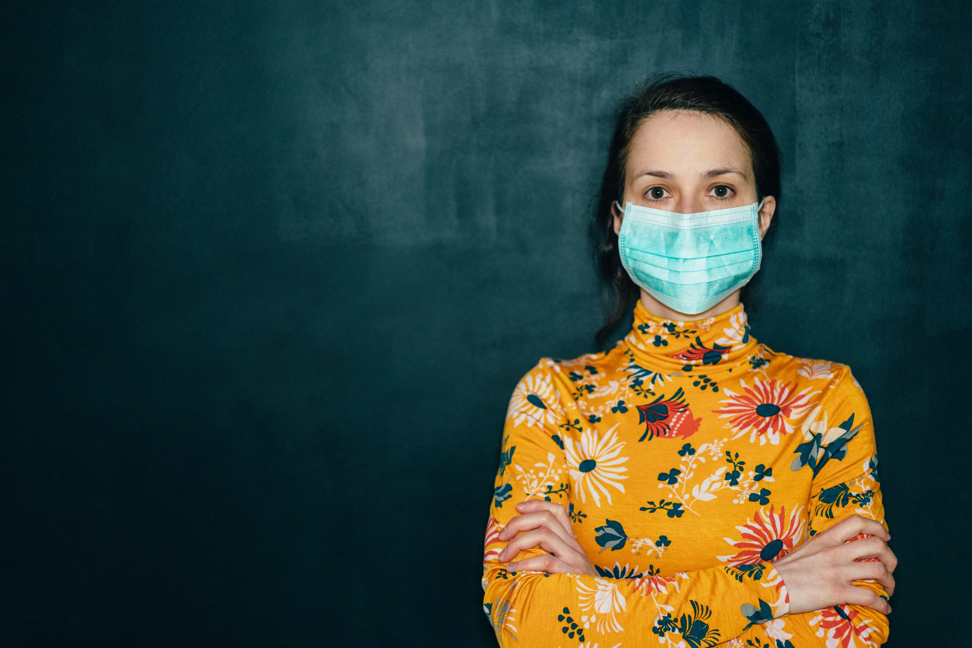

**Hello class,**

**Welcome back. We’ve missed you.**

BACK TO SCHOOL

* .......

**Monte Wilson** Incident Commander, GHC3

**It is essential that plans are in place so that students can return to school safely.**

“

May 20, 2020



**WE ARE COLLABORATING WITH PRIVATE SECTOR PARTNERS TO COLLATE BEST PRACTICES, DEVELOP RECOMMENDATIONS, AND FACILITATE SAFE ENVIRONMENTS AS STUDENTS RETURN TO SCHOOL.**

.



OUR SOLUTION:

Partner with an Atlanta school to run a pilot that follows CDC guidelines to establish best practices for returning to school (k-12).

We will subsequently roll this out to other school environments:

* Rural
* Urban
* Private
* Charter



THE PROBLEM:

Schools are closed, and a generation is facing lost access to education.

WE NEED YOUR IDEAS, TALENT, AND SUPPORT.